EXPERIMENT 4
LASER DIODE CHARACTERISTICS

AIM: T o study V/I characteristics of a LASER diode.

APPARATUS: Laser Diode Characteristics board comprises of:
1. Laser diode
2. 0-5V variable Supply for laser diode
3. 20mW Digital Optical power meter to measure optical power of Laser diode
4. 20V Digital Voltmeter to measure voltage across laser diode
5. 200mA DC Digital Ammeter to measure Laser diode Current

CIRCUIT DIAGRAM:

V/I CHARACTERISTICS OF LASER DIODE
+ -
mA
R
V

+ P
LASER DIODE
+
-

N
Theory: Introduction: A laser diode is a laser where the active medium is a semiconductor similar to that found in a light-emitting diode. The most common and practical type of laser diode is formed from a p-n junction and powered by injected electric current. These devices are sometimes referred to as injection laser diodes to distinguish them from (optically) pumped laser diodes, which are more easily produced in the laboratory. A laser diode, like 3many other semiconductor devices, is formed by doping a very thin layer on the surface of a crystal wafer. The crystal is doped to produce an n-type region and a p-type region, one above the other, resulting in a p-n junction, or diode. When an electron and a hole are present in the same region, they may recombine or "annihilate" with the result being spontaneous emission — i.e., the electron may reoccupy the energy state of the hole, emitting a photon with energy equal to the difference between the electron and hole states involved. (In a conventional semiconductor junction diode, the energy released from the recombination of electrons and holes is carried away as phonons, i.e., lattice vibrations, rather than as photons.) Spontaneous emission gives the laser diode below lasing threshold similar properties to an LED. Spontaneous emission is necessary to initiate laser oscillation, but it is one among several sources of inefficiency once the laser is oscillating.
In the absence of stimulated emission (e.g., lasing) conditions, electrons and holes may coexist in proximity to one another, without recombining, for a certain time, termed the "upper-state lifetime" or "recombination time" (about a nanosecond for typical diode laser materials), before they recombine. Then a nearby photon with energy equal to the recombination energy can cause recombination by stimulated emission. This generates another photon of the same frequency, travelling in the same direction, with the same polarization and phase as the first photon. This means that stimulated emission causes gain in an optical wave (of the correct wavelength) in the injection region, and the gain increases as the number of electrons and holes injected across the junction increases. The spontaneous and stimulated emission processes are vastly more efficient in direct bandgap semiconductors than in indirect bandgap semiconductors; therefore silicon is not a common material for laser diodes. As in other lasers, the gain region is surrounded with an optical cavity to form a laser. In the simplest form of laser diode, an optical waveguide is made on that crystal surface, such that the light is confined to a relatively narrow line. The two ends of the crystal are cleaved to form perfectly smooth, parallel edges, forming a Fabry-Perot resonator. Photons emitted into a mode of the waveguide will travel along the waveguide and be reflected several times from each end face before they are emitted. As a light wave passes through the cavity, it is amplified by stimulated emission, but light is also lost due to absorption and by incomplete reflection from the end facets. Finally, if there is more amplification than loss, the diode begins to "lase". -

Electrical Characteristics: The V/I Curve.
The voltage drop across the laser is often acquired during electrical characterization. This characteristic is similar to the analogous characteristic of any other type of semiconductor diode and is largely invariant with temperature, as depicted in Figure 1. (Note: Diode laser manufacturers usually place the forward voltage on the X axis, in compliance with conventional practice in the electronics industry for other types of diodes. Companies manufacturing instrumentation to characterize diode lasers often present the curve in the manner of Figure , with the forward current on the X axis. Conventional electronics people would call this an I/V curve, rather than accept our nomenclature of a V/I curve). The typical voltage drop across a diode laser at operating power is 1.5 volts. V/I data are most commonly used in derivative characterization techniques.

Procedure for V/I characteristics of a laser diode:
- Connect the Laser diode circuit as per the circuit diagram:
- Slowly increase supply voltage using variable Power supply using coarse and fine knobs.
- Note down current through the laser diode at increasing values of Laser diode voltage of 0.5V, 1.0V, 1.5V, 2.5 V.
- Do not exceed current limit of 30mA else the laser diode may get damaged.
- Plot a graph of Laser diode voltage v/s Laser diode current.(As this experiment is conducted at room temperature, only one graph for a single temperature will be obtained.)
For V/I characteristics of LASER

Sr. No. | LED Voltage  V (volt) | LED Current  I (Ma)
1
2
3
4
5
6
7
8
9

MODEL GRAPH:

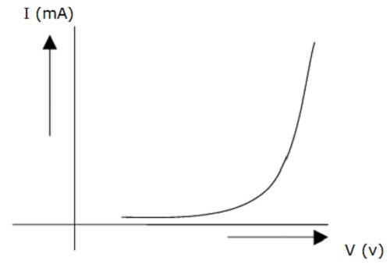
RESULT: V/I characteristics of LASER diode is studied.

